Reconstruction of a local road from the intersection with the road to dam Turija to the center of the village of Dobrosinci-Municipality of Vasilevo
Total road length: L = 1320 m
- Design speed: 30 km/h
- Road profile width: 5.00 m
- Maximum cross slope: 2.50 %
- Maximum longitudinal slope: 10.69 %
Pavement Structure
- BNHS 16 – asphalt layer: d = 7cm
- Base layer of buffer layer under the roadway: 35cm
- Base layer of buffer layer under the sidewalks: 20cm

The subject street is part of Т4D5.
The work is being carried out by the construction DPTU ЕSKAVATORI – MK Dooel Skopje. The value of the signed contract is 16,421,768 denars.

Project Overview

Preparatory work:

- Securing and marking the route

Lower and upper structure:

- Mechanical excavation of humus, with transport to the landfill (for road widening)
- Mechanical excavation of the existing roadway
- Subsoil/bed preparation
- Embankment preparation
- Installation of a buffer layer (under the roadway) d=35cm
- Installation of concrete curbs 18/24
- Installation of buffer layer (under sidewalks) d=20cm
- Installation of BNHS layer 16 d=8cm
- Installation of sidewalk concrete curbs 8/22
- Installation of paver elements on sidewalks d=6cm

Drainage:
- Installation of drainage pipes f150 (with excavation, filter material and backfilling
- Drainage from km.0+902-1+32

Traffic signals:

- Installation of traffic signs
- Marking of horizontal signaling

Additional quantities:

- Construction of an embankment, with procurement of the material (improved subgrade)
- Construction of two drainage outlets at km.0+958 and km.1+026 in accordance with the Technical Solution for Road Drainage.

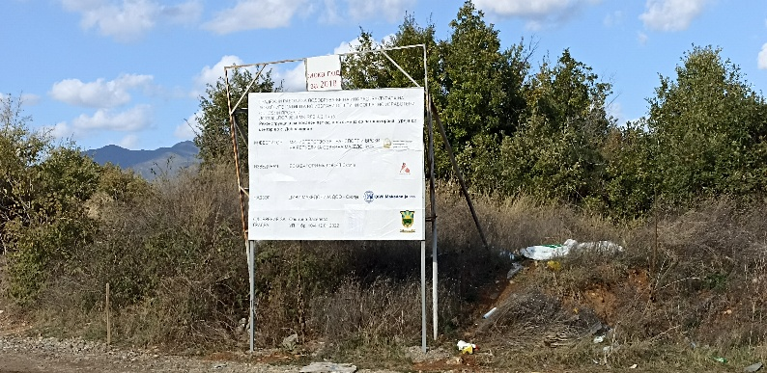 | 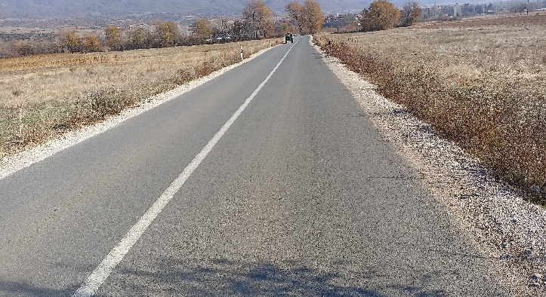
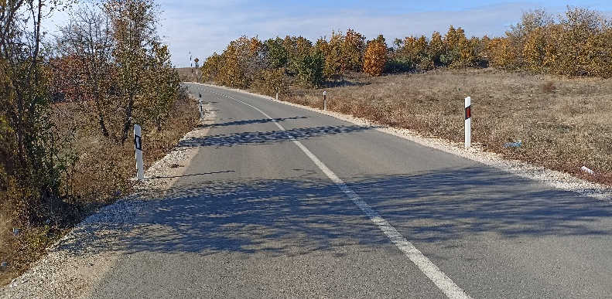 | 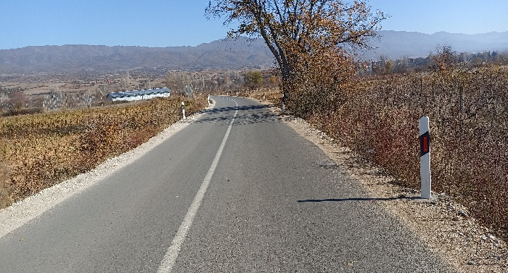
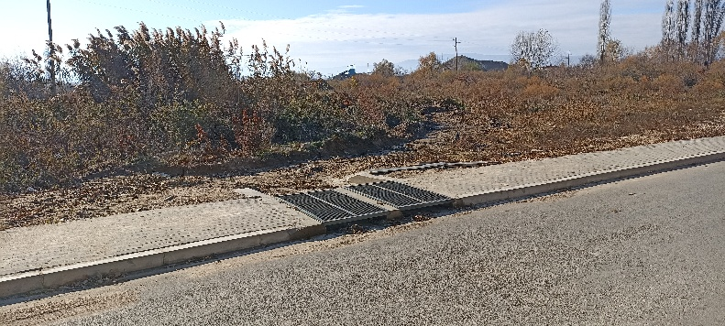 | 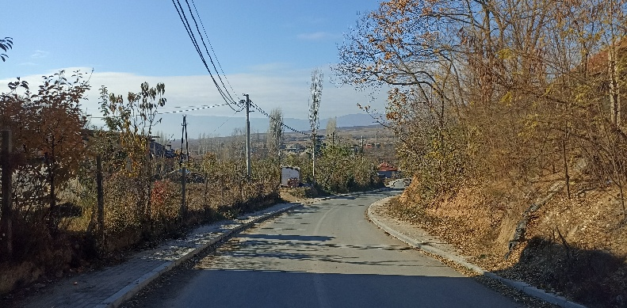
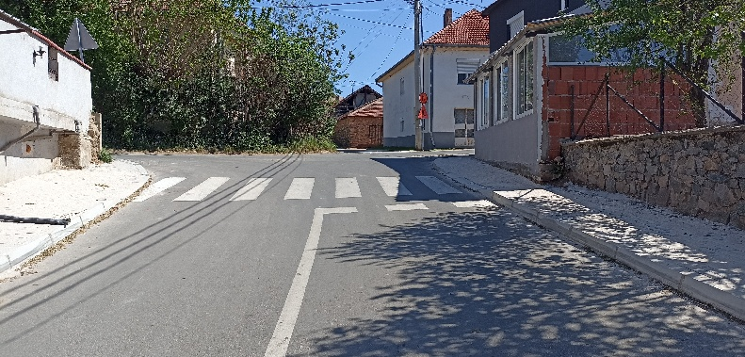 | 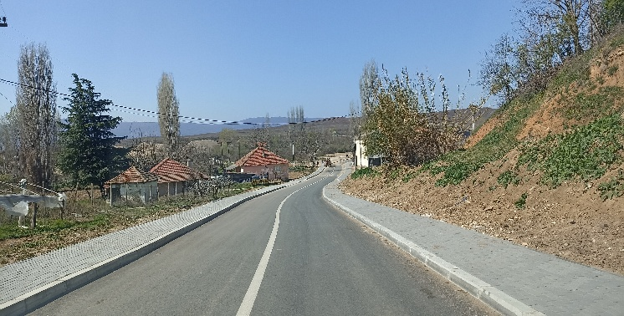
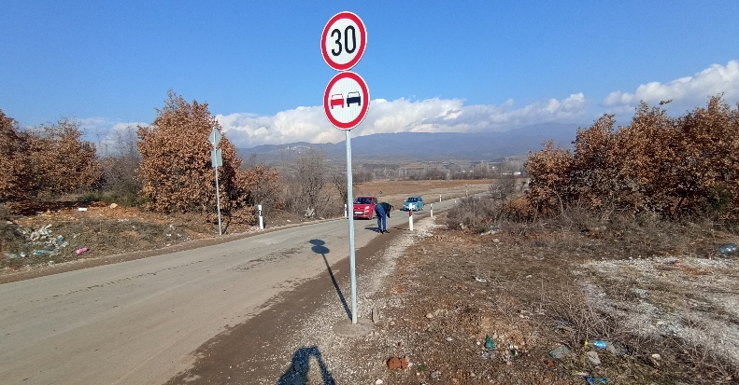 | 