Construction of local road,, Gavrilo Gavrilski”- Municipality of Sveti Nikole
Total road length: L = 332.84 m
- Design speed: 30 km/h
- Road profile width: 5.50 m
- Maximum cross slope: 2.50 %
- Maximum longitudinal slope: 9.35%
Pavement Structure
- BNHS 22 – asphalt layer: d = 7cm
- Base layer of buffer layer under the roadway: 30cm
- Base layer of buffer layer under the sidewalks: 20cm

The subject street is part of Т4D5.
The work is being carried out by the construction DPTU ЕSKAVATORI – MK Dooel Skopje. The value of the signed contract is 7,840,222 denars.

Project Overview

Preparatory work:

- Securing and marking the route
- Dislocation of existing concrete columns

Lower and upper structure:

- Mechanical excavation of earth in a wide excavation 3-4 floors.
- Making a bed
- Making an embankment
- Leveling existing manholes
- Installing a buffer layer (under the roadway)d=30см
- Installation of concrete curbs18/24
- Installation of buffer layer (under sidewalks) d=20см.
- Installation of BNS22 layer d=7см.
- Installation of AB11 layer d=5см.
- Installation of sidewalk concrete curbs 6/20
- Installation of paver elements on sidewalks

Drainage:
- Installation of drainage pipes f150 (with excavation, filter material and backfilling
- Procurement and installation of street drains
- Production of absorption wells (4 pcs.)
Traffic signals:

- Installation of traffic signs
- Marking of horizontal signaling

Additional quantities:

- Construction of an embankment, with procurement of the material (improved bedding)
- Procurement and installation of iron manhole covers

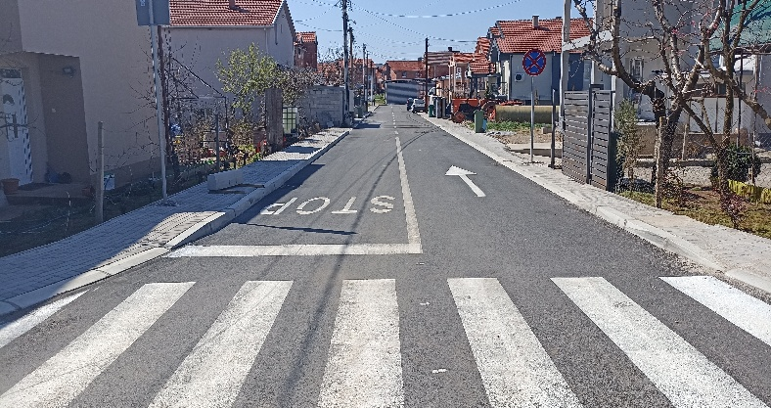  Street “Gavrilo Gavrilski” | 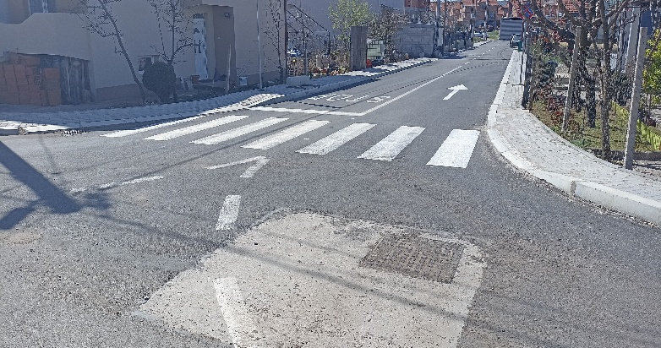  Street “Gavrilo Gavrilski”
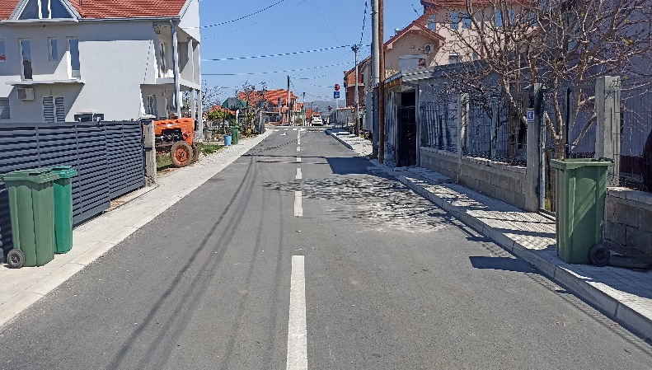  Street “Gavrilo Gavrilski” | 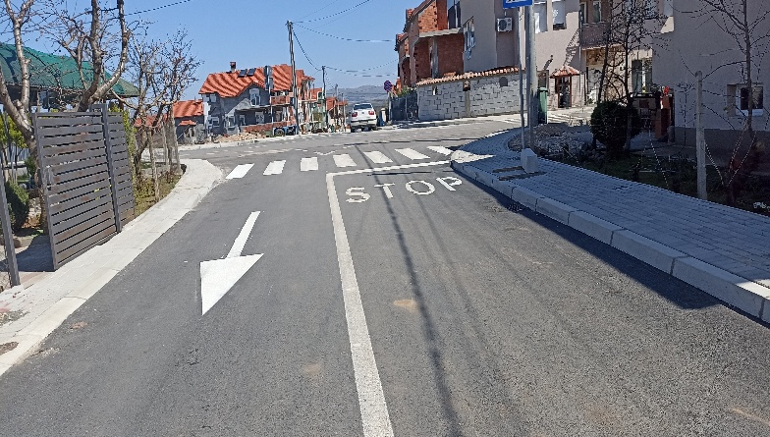  Street “Gavrilo Gavrilski”
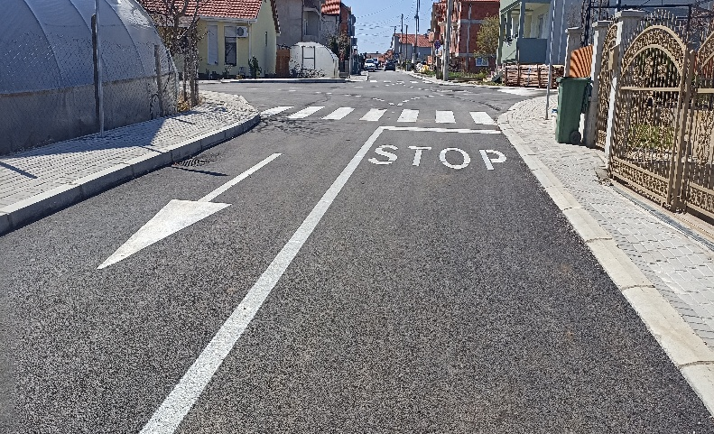
Street “Gavrilo Gavrilski”

