Construction of a local road from the local road for the village of Banjica to the village of Otistino - Municipality of Chashka

Total road length: L = 212 m
- Design speed: 30 km/h
- Road profile width: 4.50 m
Pavement Structure
- BNHS 16 – asphalt layer: d = 7cm

The subject street is part of Т4D5.
The work is being carried out by the construction DPTU ЕSKAVATORI – MK Dooel Skopje. The value of the signed contract is 2,846,182 denars.

Project Overview

Preparatory work:

- Securing and marking the route

Lower and upper structure:

- Mechanical excavation of earth in a wide excavation 3-4 floors.
- Subsoil preparation
- Embankment preparation (improved bed 15cm)
- Installation of buffer layer (under the roadway) d=30cm
- Installation of BNHS 16 layer d=7cm
- Construction of shoulders 1x0.5cm
- Construction of gutter d=0.5cm

Traffic signals:

- Installation of traffic signs

Additional quantities:

- Concrete curbs 18/24 (on the left side) for gutter
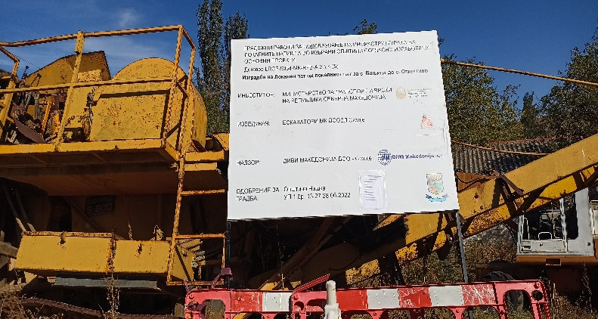 | 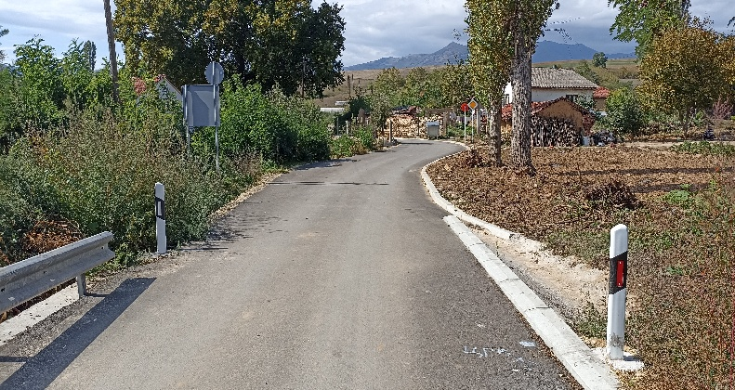
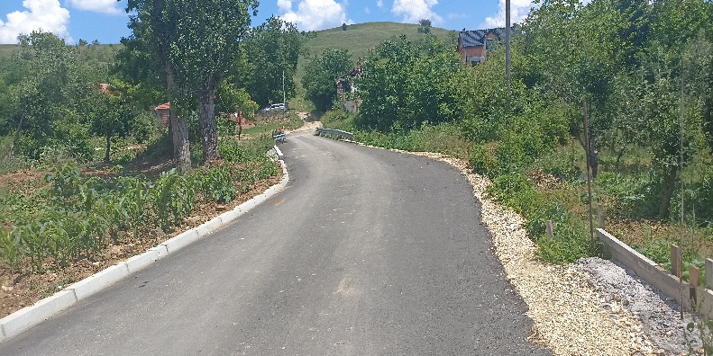 | 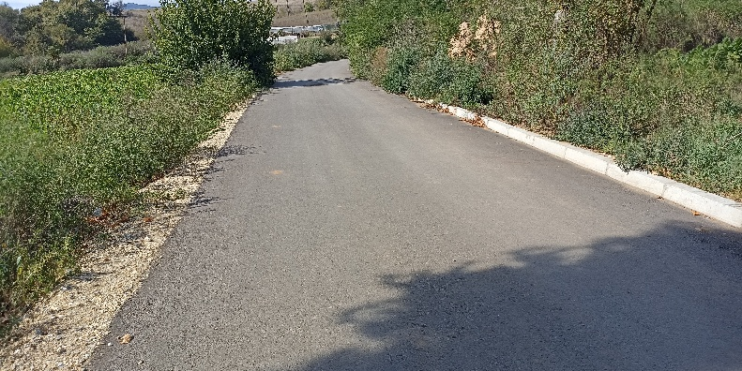
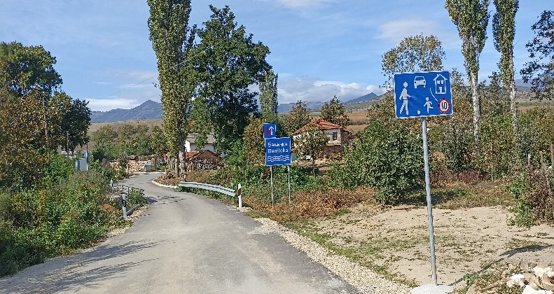 | 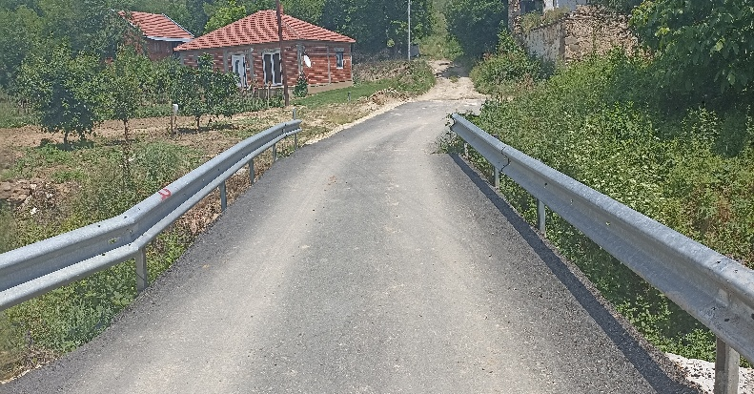
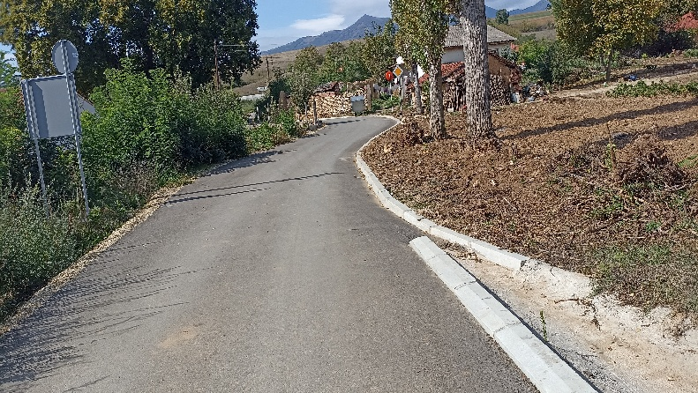 | 