Reconstruction of local road,, Street 12” in Karatmanovo- Municipality of Lozovo
Total road length: L = 133 m
- Design speed: 30 km/h
- Road profile width: 3.50 m
Pavement Structure
- BNS 16 – asphalt layer: d = 7cm
- Base layer of buffer layer under the roadway: 30 cm

The subject street is part of Т4D5.
The work is being carried out by the construction DPTU ЕSKAVATORI – MK Dooel Skopje. The value of the signed contract is 780,161denars.

Project Overview

Preparatory work:

- Securing and marking the route

Lower and upper structure:

- Mechanical excavation of earth in a wide excavation 3-4 floors.
- Making subsoil/ bedding
- Making an embankment (improved bedding 15 cm)
- Leveling existing manholes
- Installing a buffer layer (under the roadway)d=30см
- Installation of BNHS 16 layer d=7см.
- Construction of banks 0.5 cm

Traffic signals:

- Installation of traffic signs

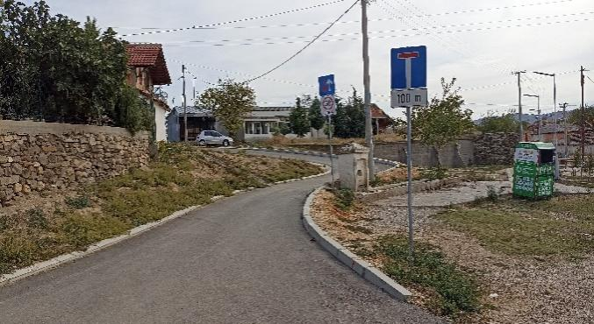  ул.12 | 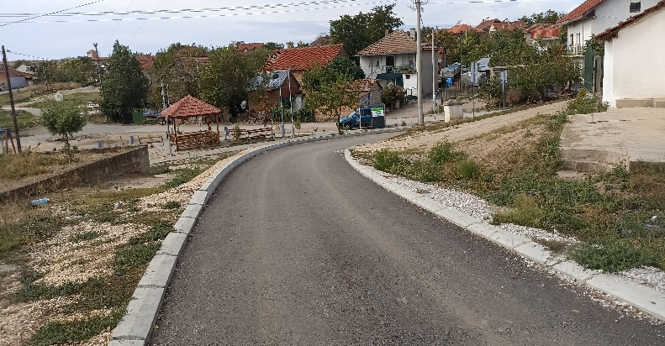  ул.12

